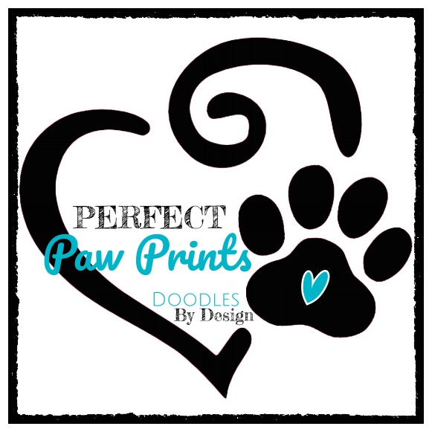

HEALTH GUARANTEE and SALES CONTRACT FOR PUPPY

New Puppy Owner:

Name:

Email:

Phone:

Address: City: State: Zip:

E-Mail

Seller Name: SHALEES and JOEL JOHNSON
Address: 2480 S 1100 W SYRACUSE, UTAH 84075
Phone: (801) 725-7062
Email: Shalees@me.com

UPON PAYMENT of the sum of paid by Buyer to Seller, receipt of which is hereby acknowledged, Seller grants, sells, conveys, and transfers ownership of the following dog/puppy to the Buyer:
Name of Dog: Breed:
Color: Date of Birth:
Sire: Dam:
Sex: New Name:
Date Acquired: State of Health:

TERMS AND CONDITIONS
PERFECT PAW PRINTS HAS THE RIGHT OF REFUSAL, FOR ANY REASON, AT ANY GIVEN TIME, TOWARDS ANY ADOPTION.

THE PURPOSE OF THIS CONTRACT IS TO DEFINE THE ADOPTION CONDITIONS OF THE BUYER AND THE BREEDER. THE BUYER UNDERSTANDS THIS CONTRACT IS A LEGALLY BINDING AGREEMENT AND NO CONTENTS THEREOF MAY BE ALTERED WITHOUT WRITTEN AUTHORIZATION OF THE BREEDER.

BE IT KNOWN, that SHALEES JOHNSON (“Breeder”), and (“Buyer”), hereby agree, on date as follows: The Breeder hereby sells to the Buyer, for the amount of , A puppy from the Perfect Paw Print breeding lines.

The following conditions apply to the sale of the aforementioned Puppy:
1. Retainer Fee, Payment of Purchase Price, and Fees.
Buyer has paid a Retainer Fee of with payment of the balance of delivery due upon release of the puppy to the Buyer.
The expected delivery date is on or around , or such other date as the parties may mutually agree.
Final payment of the amount is due one week prior to the placement of the puppy.
Buyer acknowledges and agrees that Buyer will forfeit the Retainer Fee and any rights to the puppy if:
(A) Buyer fails to complete the purchase of the puppy for any reason, or (B) Buyer fails to pay the balance of the purchase price within days of the agreed delivery date.
In either event, Seller shall be free to sell the puppy to another party. In the event that the puppy is not available due to sickness, death, or any other circumstance owing to the fault of Seller, Buyer’s deposit will, at Buyer’s option, be either (i) refunded, or (ii) transferred to another puppy or the next litter of puppies.
A boarding fee of per week will be charged for each week the puppy is boarded by Seller past the agreed delivery date.
2. Transfer of Ownership
Upon payment in full of the purchase price, Seller shall promptly take all actions required to officially transfer ownership of the puppy to Buyer.
In the event that the Buyer is unable to care for, or give the said puppy a proper home at any time and needs to re-home the puppy; they will notify the Seller. The Seller will either:
(A) Re-establish ownership of the puppy (no refund will be given) Or
(B) Help owner find a proper home for the puppy

3. Seller’s Representations and Warranties Seller represents and warrants to Buyer that:
(A) Seller is the legal and true owner of the puppy and that Seller has full right and authority to sell the puppy.
B) The puppy is being sold free and clear of any lien, security interest, charge, or other encumbrance.
(C) Health Guarantee:

We guarantee that the said puppy will be in good health and current on vaccinations/wormings for age when ownership is transferred to the Buyer. Buyer has 3 business days from delivery date to have the puppy examined by a licensed veterinarian, at buyers sole cost. If the Buyer's Veterinarian should find this puppy to have a life-threatening illness or disease (excluding parasites, Coccidia, Giardiasis, Bordetella,(or any airborne illness), cherry eye, UTI, or an easily treated illness, many of which can be brought on by the stress of being re-homed), or is found to have a life altering genetic defect within 3 business days of the puppy leaving my home, the buyer will have 7 days to return the puppy to the breeder, along with Vet record of illness and any/all registration papers, etc. that were given with the puppy. A full refund of the price of the puppy will be given. The breeder will always have the option of having the diagnosis confirmed by a Veterinarian of her choice before a refund is issued.

Please take caution as to where you take your new puppy until the entire series of puppy shots has been given (usually between 14-18 weeks of age). Avoid Pet Stores, dog parks, rest areas, etc. I know people want to show off their new puppy but it is really best for your puppy's health to avoid these places until he/she is completely immunized!! There will be no refunds given when your puppy is given back to us for any reason, other than a genetic life threatening defect. You will have an option to have credit with us for up to two years, in order to choose a puppy then.

The breeder guarantees the dog’s health for 3 days after the release of the dog in the case of communicable disease. Breeder will not be responsible for Parvo, Distemper or Corona Virus after 72 hours of release of puppy, these diseases are highly contagious and can be contracted immediately after leaving the breeder. We will not be responsible for any illnesses that are diagnosed after this time period. This guarantee does not include non-life threatening or temporary disorders such as bites, injuries, parasites, etc.
(D) Genetic Guarantee: SELLER’S REPRESENTATIONS: This puppy is guaranteed to the original purchaser against debilitating or life-threatening hereditary/congenital diseases including hip dysplasia, vWD (affected), hereditary, debilitating cardiac issues and/or hereditary disabling eye diseases until he/she reaches 2 yrs. of age. Please note that I do not guarantee for proper bite, and/or against umbilical hernias, as these do not affect the "pet quality" of the dog and are not life-threatening.

If this puppy/dog is found to have a debilitating, life-threatening, hereditary/congenital disease, the breeder will replace the puppy with a new one of equal value, when available. Please know that I will NEVER ask you to return your beloved pet in order for this warranty to be fulfilled. I do, however, require that the dog be spayed/neutered prior to receiving a replacement puppy. Documentation must be provided by a licensed Veterinarian (by OFA or PennHip for hip/elbow issues, a Certified Veterinary Cardiologist for Cardiac issues or a certified canine Ophthalmologist for eye issues).

It is understood that the breeder is not responsible for Vet bills or shipping/transportation costs. The breeder may have the said puppy examined by a licensed Veterinarian of her choice to verify the diagnosis. This guarantee is void if the dog is found to be overweight and/or not fed a quality diet. The buyer also agrees to hold off on any strenuous, repetitive exercise (agility, long walks/hiking, etc.) until the dog is at least one (1) year of age, as this is hard on hips/joints of large breed dogs and will void this health warranty. Not included in this warranty are health issues that may be caused by environmental factors such as allergies, autoimmune disorders, trauma, abuse and failure to maintain the general health of the dog.
Under no circumstances shall the Seller be liable to the Buyer or to any third party for a dog that has been subjected to abuse, accident, negligence, or any damages resulting from or in any manner related to the dog. This warranty does not include viral illnesses, infections, improper bites, or hernias. This should be considered a reasonable expectation and the Buyer’s financial responsibility. The Seller has done everything possible to avoid and clear parasites. This agreement does not include any illness due to the ingestion of foreign objects, food, chemicals, physical injury, or issues whose cause is unknown or may have an environmental link. Upon execution of this contract all veterinary care and its associated costs are the sole and exclusive responsibility of the Buyer.
Buyer's Responsibility

*The buyer agrees that their puppy will be housed indoors.

*The buyer agrees to feed their puppy only a premium quality food.

* The buyer agrees to keep their puppy at a healthy weight.

*The buyer agrees to make and keep annual veterinary appointments for their puppy and to keep current on vaccinations and heart-worm preventative as recommended by his/her licensed Veterinarian.

*The Buyer is encouraged to provide basic obedience training with their puppy within the first year of owning their dog.

*The Buyer agrees to postpone strenuous, repetitive exercise until after their puppy has reached one year of age.

*The buyer agrees that the puppy will never be taken to a dog shelter, pound or any like facility or used for research.

The breeder understands that, at times, circumstances may arise where an owner cannot keep his/her dog. If this occurs, the buyer agrees to find a suitable home for the said puppy/dog so long as the dog has been spayed/neutered per contract. The breeder is here for the life of the dog and will help the buyer, in any way possible, to place the dog in a new loving home or will welcome the dog back to re-home it. This health warranty is void if the puppy is transferred to a new owner before the age of 2 years.

(E) Pet Puppies are sold under strict spade/neuter contract
This puppy is being sold as a family pet and does not convey with breeding rights. This dog must be spayed or neutered by 9 months of age; failure to do so will void the health warranty. Proof of spaying/neutering by 9 months of age must accompany any request for warranty reimbursement. If this puppy is bred, the purchaser agrees to pay the seller ten times the purchase price of this puppy for every litter produced. If, for any reason, a dispute about the said puppy goes to court, it shall be taken up in the Davis County, Utah courts.

I have read and understand the terms/conditions of this agreement and understand that by signing this agreement it becomes a binding contract. Any/all disputes will be taken up in the court system in Davis County, Utah.

Signature or electronic signature of Buyer: Signature or electronic signature of Seller:

Date: Date:

